**Activity 12.5 - Mohammed Abdin**

**Submission Instructions:**

Your submission for this assignment should be a Word document that includes the following screenshots, each labeled for the step that the screenshot represents:

1. Provide a screenshot to show that you downloaded and opened the [Activity 12.5 Files](https://classroom.emeritus.org/courses/10605/files/3007216/download) folder in VS Code.

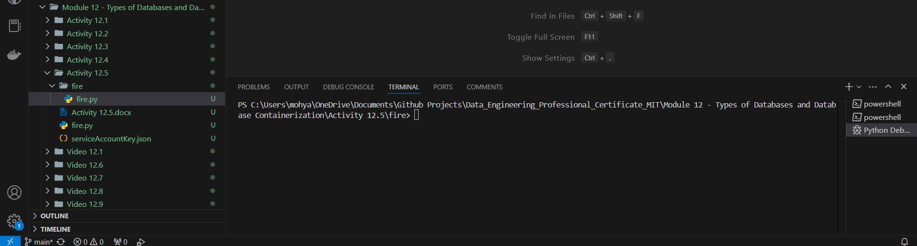

1. Provide screenshots to show that you created the Activity12-5 project in Firebase.

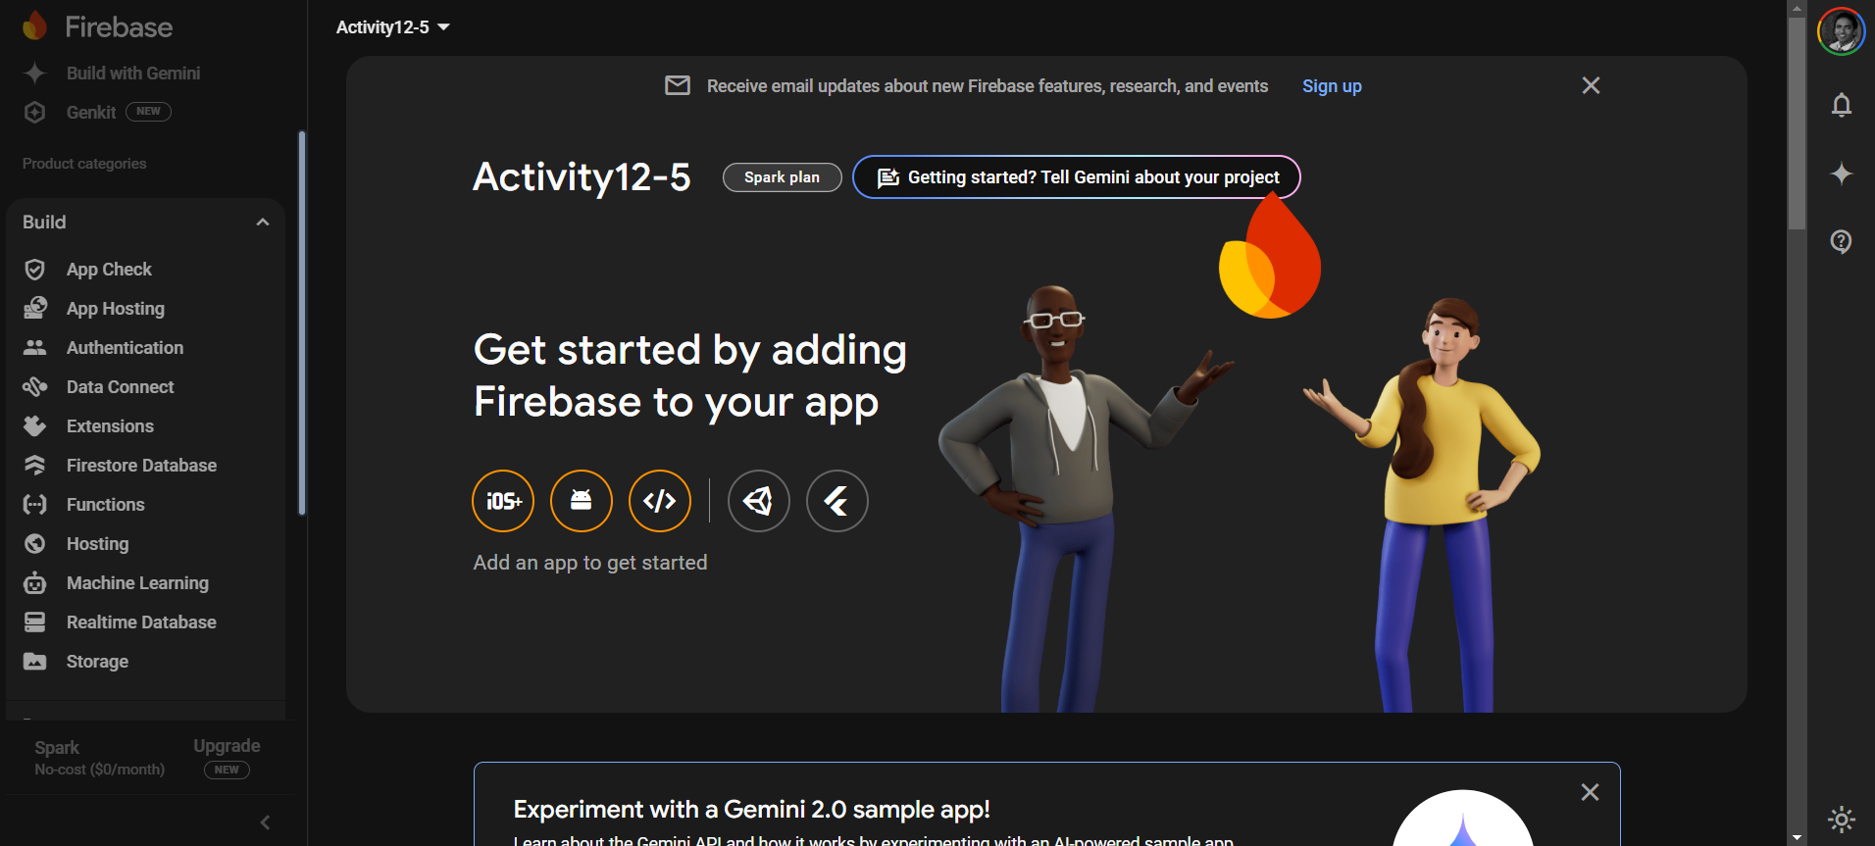

1. Provide two screenshots: One screenshot showing that you navigated to the correct page in Firebase to obtain the private *key* and one screenshot showing that you copied the file into the serviceAccountKey.json file correctly.
2. Private Key page

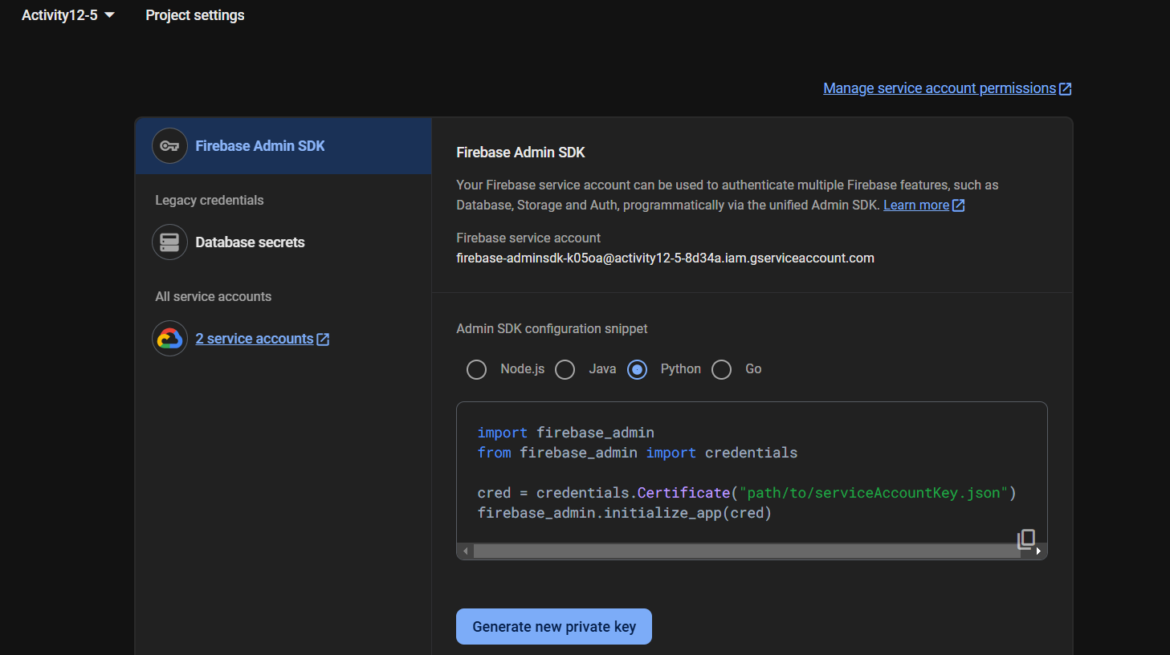

1. JSON file update

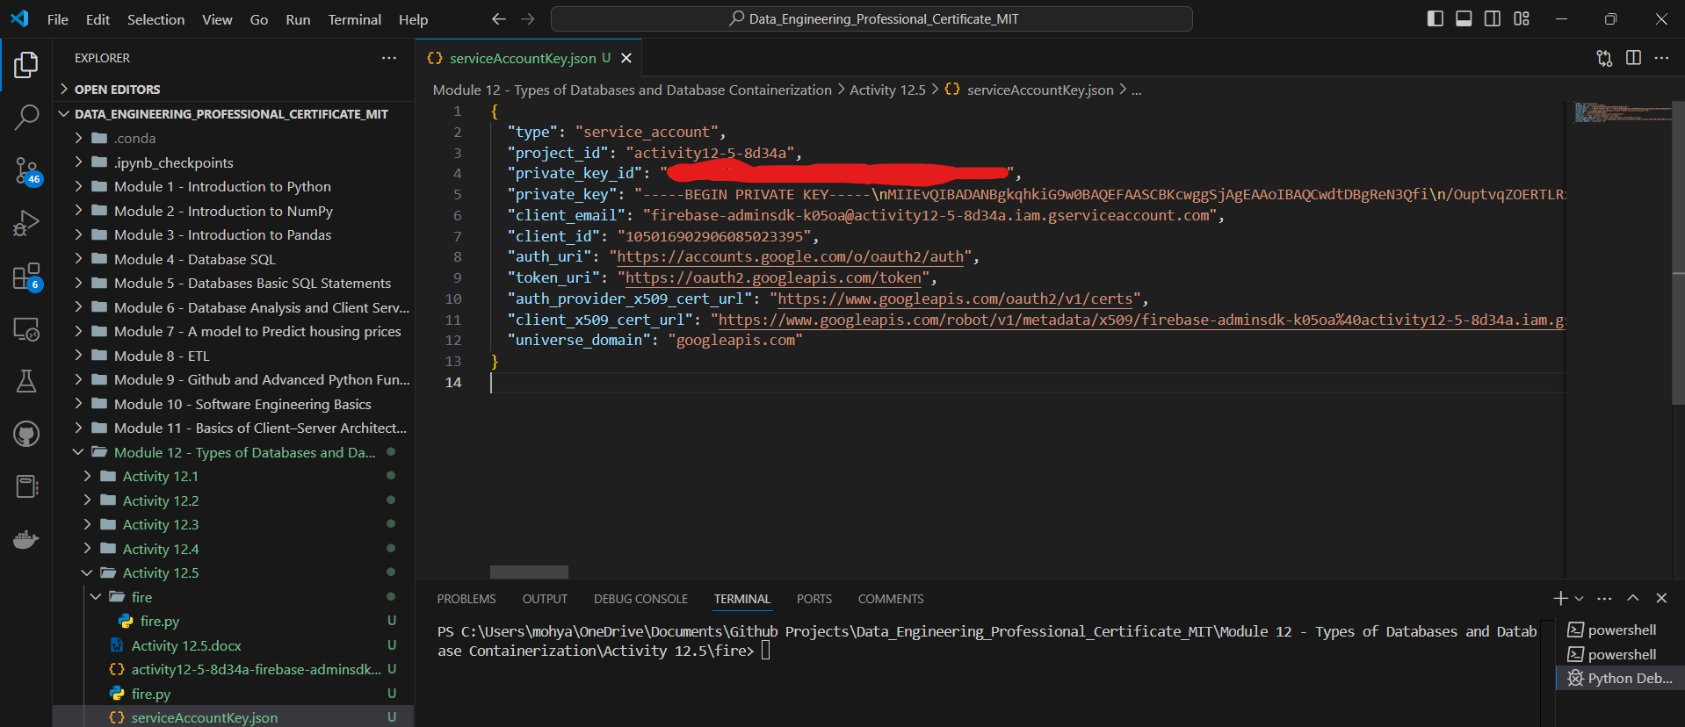

1. Provide a screenshot to show that you created an empty Realtime database for your project in Firebase.

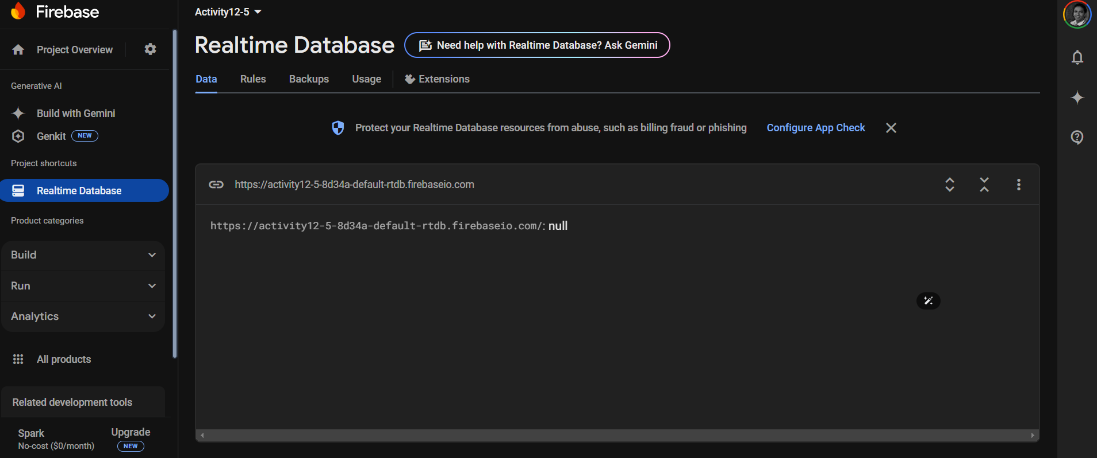

1. Provide a screenshot to show that you updated the databaseURL field in the fire.py file with the URL you copied.

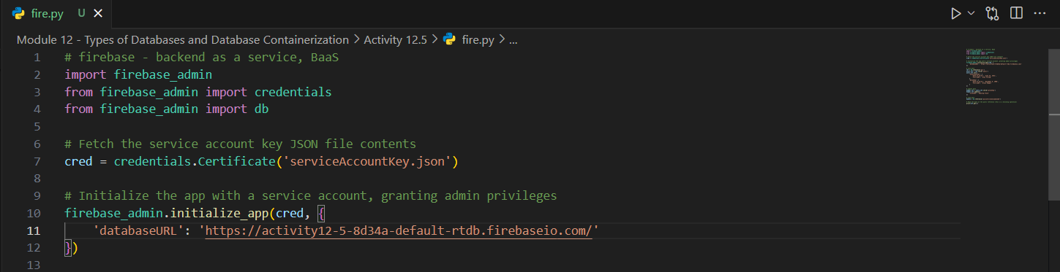

1. Provide a screenshot to show that you updated the entries in the fire.py file.

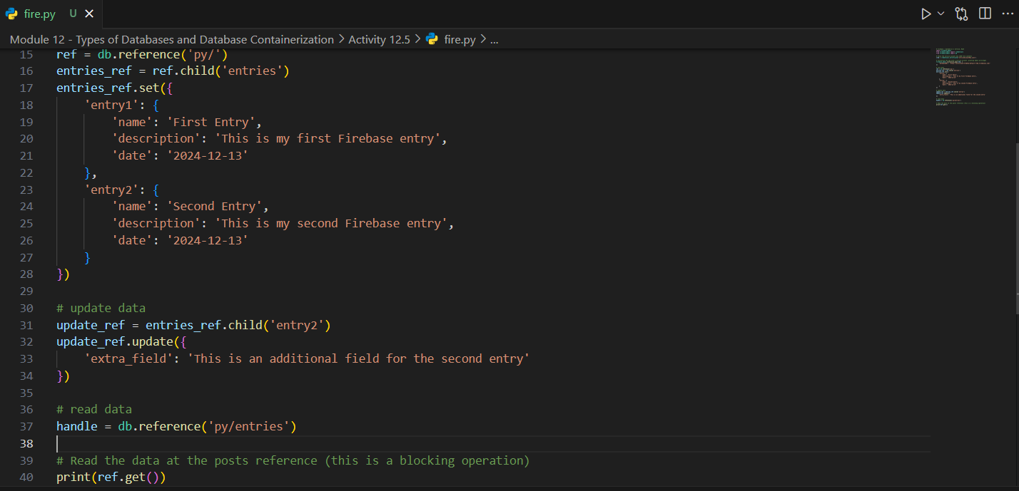

1. Provide a screenshot of your Terminal window to show that you ran the correct command to write to your database in Firebase.

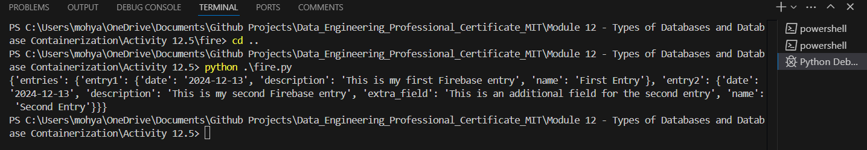

1. Provide a screenshot of your Terminal window to show that your database has been written as expected.

